revista de Biología Tropical
Impact of jaguar Panthera onca (Carnívora: Felidae) predation on marine turtle populations in Tortuguero, Caribbean coast of Costa Rica
Stephanny Arroyo-Arce^{1,2}* & Roberto Salom-Pérez1. Proyecto Conservación del Jaguar en el Noreste Caribeño de Costa Rica, 126-3100 Santo Domingo, Heredia, Costa Rica; sturnina@gmail.com
2. Global Vision International/GVI Costa Rica, 230-60601 Quepos, Costa Rica
3. Panthera Costa Rica, 8-3870-1000 San José, Costa Rica; rsalom@panthera.org * Correspondence
Received 20-X-2014. Corrected 01-IV-2015. Accepted 06-V-2015.
Abstract: Little is known about the effects of jaguars on the population of marine turtles nesting in Tortuguero National Park, Costa Rica. This study assessed jaguar predation impact on three species of marine turtles (Chelonia mydas, Dermochelys coriácea and Eretmochelys imbricata) that nest in Tortuguero beach. Jaguar predation data was obtained by using two methodologies, literature review (historical records prior the year 2005) and weekly surveys along the 29 km stretch of beach during the period 2005-2013. Our results indicated that jaguar predation has increased from one marine turtle in 1981 to 198 in 2013. Jaguars consumed annually an average of 120 (SD= 45) and 2 (SD= 3) green turtles and leatherbacks in Tortuguero beach, respectively. Based on our results we concluded that jaguars do not represent a threat to the population of green turtles that nest in Tortuguero beach, and it is not the main cause for population decline for leatherbacks and hawksbills. Future research should focus on continuing to monitor this predator-prey relationship as well as the factors that influence it so the proper management decisions can be taken. Rev. Biol. Trop. 63 (3): 815-825. Epub 2015 September 01.
Key words: Chelonia mydas, Dermochelys coriacea, Eretmochelys imbricata, marine turtles, Panthera onca, predator-prey interaction, Tortuguero National Park.
Predator-prey interactions play a critical role in the dynamics of the ecosystems (Heithaus, Wirsing, Thomson, & Burkholder, 2008). It is well known that predators can have a direct effect on prey due to consumption of prey individuals (Nelson, Matthews, & Rosenheim, 2004; Heithaus et al., 2008). However, predators can also induce behavioral changes in prey which may lead to shift in activity patterns, reduction in foraging time or spatial and temporal redistribution, among others (Nelson et al., 2004; Heithaus et al., 2008, Valeix et al., 2009; Fitzpatrick et al., 2012). Nonetheless, the effect of predators on adult marine turtles has been overlooked since this interaction can be difficult to observe and quantify (Heithaus et al., 2007; Hays, 2008; Fitzpatrick et al., 2012; Bornatowski, Heithaus, Batista, & Mascar-enhas, 2012).
Heithaus et al. (2008) suggested that predators of adult marine turtles can influence turtle population sizes in spite of low predation rates. Pitman and Dutton (2004) also indicated that even opportunistic predation by killer whales (Orcinus orca) should be considered a factor in recovery efforts for the leatherback (Der-mochelys coriacea) population in the Northeast Pacific. In turn, Fergusson, Compagno and Marks (2000) mentioned that the impact of white shark (Carcharodon carcharias)
Rev. Biol. Trop. (Int. J. Trop. Biol. ISSN-0034-7744) Vol. 63 (3); 1-825, September 2015
815

predation upon marine turtle populations in the Mediterranean sea is unknown but probably extremely small compared to other sources of mortality (e.g. anthropogenic causes). Ortiz, Plotkin and Owens (1997) indicated that American crocodile (Crocodylus acutus) predation on the olive ridley sea turtles (Lepidochelys olivacea) have little or no effect on the nesting population at Playa Nancite in Costa Rica. They also highlighted that this interaction may enhance the survival of the local population of crocodiles. Heithaus et al. (2007) also emphasized that the loss of marine turtle predators could result in a negative impact in the ecosystem dynamics.
Although jaguar (Panthera onca) predation on marine turtles has been recorded throughout America (Autar, 1994; Carrillo, Morera, & Wong, 1994; Fretey, 1977; Troeng, 2000a; Keeran, 2013; Cuevas, Faller-Menen-dez, & Angulo, 2014) it seems that predation rates are not significantly large enough to influence the marine turtle population. However, in recent years this predator-prey interaction has drawn attention in Tortuguero National Park, Costa Rica (Verissimo, Jones, Chaverri, & Meyer, 2012; Barca, 2013; Arroyo-Arce, Guilder, & Salom-Perez, 2014). Troeng (2000a) mentioned that the green turtle (Chelonia mydas) population that nests in Tortuguero is not significantly threatened by jaguar predation. Contrary to this, Verissimo et al. (2012) indicated that jaguars should rank alongside, if not higher than, other documented threats. In this paper, we evaluated the impact of jaguar predation on three species of marine turtles (C. mydas, D. coriacea, Eretmochelys imbricata) that nest in Tortuguero beach. We also discuss how the availability of marine turtles may be affecting the local jaguar population.
MATERIALS AND METHODS
Study site: This study encompassed approximately 29 km of coastline in Tor-tuguero National Park, on the Northeastern Caribbean coast of Costa Rica (10°32'28" N - 83°30'08" W). The beach extends from the
Tortuguero River mouth in the North, to the Jalova River mouth in the South, and it is bordered by tropical wet forest (Holdridge, 1969). Average temperatures are between 25 ³
ºC to 30 ºC with a mean annual precipitation of 6 000 mm (Bermudez & Hernandez, 2004).
Data collection: Data was collected by using two methodologies. First, we reviewed the existing literature in order to obtain records on predation of marine turtles by jaguars in Tortuguero National Park prior to the year 2005. For this we only considered reliable sources, including reports and scientific publications. Secondly, weekly surveys were conducted along the beach from 2005 to 2013. For logistic reasons, between 2005 and 2009 the starting point of the survey was alternated between the North and South ends, while all surveys after January 2010 started at the South end. The pre-existing turtle monitoring program had divided the beach along its length by permanent marked signs into 0.8 km sections running North to South (Fig. 1). These sections we considered our sampling units.
Surveys consisted of recording data on presence or absence of jaguars by counting identifiable jaguar tracks on each sampling unit. Predated marine turtles by jaguars (hereafter known as kills) were also recorded by counting marine turtle carcasses on each sampling unit. When a carcass was found it was examined for evidence of jaguar predation (e.g. bite marks on the neck, drag marks, jaguar tracks). It is important to highlight that the jaguar is the only felid recorded in Tortuguero beach that predate marine turtles. If it was determined to be the result of jaguar predation the marine turtle species was recorded.
In order to avoid duplication of carcasses only green turtles that were estimated to have being killed in less than seven days were recorded. Due to the fact that predation on leatherbacks and hawksbills occurs to a lesser extent and therefore duplication is unlikely to occur, all carcasses were recorded regardless of the number of days that passed since they were predated. See Verissimo et al.
2
Rev. Biol. Trop. (Int. J. Trop. Biol. ISSN-0034-7744) Vol. 63 (3): 815-825, September 2015
©®©
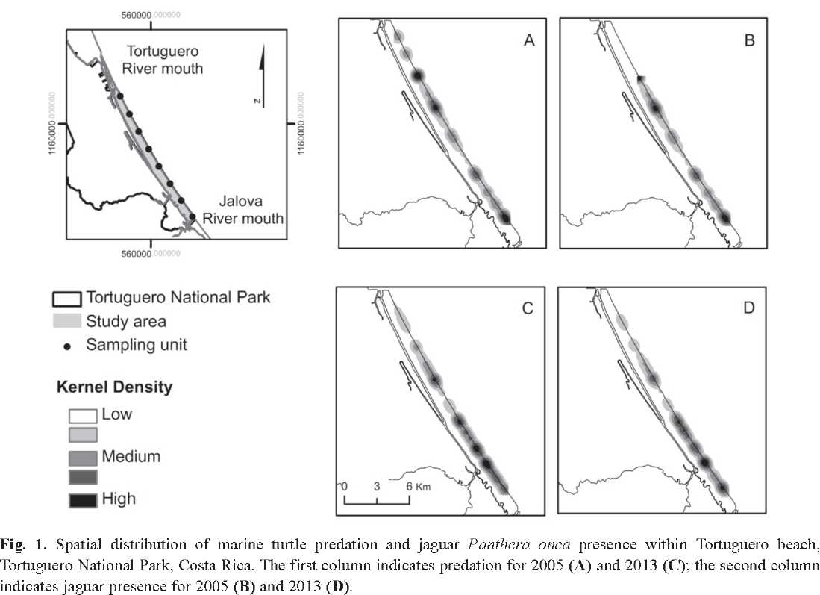
(2012), Arroyo-Arce and Thomson (2015) for a throughout description of the methodology.
Jaguar impact on marine turtle nesting population: For green turtles, annual nesting population estimates were calculated based on Troeng and Rankin's (2005) methodology. Predation estimates were determined using Equation A. For leatherbacks, annual nesting population estimates were calculated based on Spotila et al.'s (1996) methodology. Predation estimates were determined using Equation B. Jaguar impact on hawksbills was not estimated because the clutch frequency for the studied rookery is unknown.
Equation A: P . =Nest_{C} /6, P =Nest_{C}
¹ min Cm.season ' max Cm.
/2.8, Pre . =Kills_{C} *100/P ,
season min Cm max
Pre =Kills_{C} *100/P .
max Cm min
^{Equation} ^{B:} ^{P}est =^{Nest}Dc.season^{/5, Pre}est=^{Kills}Dc*^{100/P}est.
where P_{mm}= minimum annual green turtle nesting population estimates, Nest_{Cm} _{season}= annual green turtle nest number estimated for Tortu-guero beach according to Sea Turtle Conservancy reports (Sea Turtle Conservancy, 2014; E. Harrison, personal communication, May 6, 2014), 6= maximum estimated annual clutch frequency for green turtles (Troeng & Rankin, 2005), P_{max}= maximum annual green turtle nesting population estimates, 2.8= minimum estimated annual clutch frequency for green turtles (Troeng & Rankin, 2005), Pre_{min}= minimum annual green turtle predation estimates, Kills_{Cm}= total number of green turtles predated per year, Pre_{max}= maximum annual green turtle predation percentage estimates, P_{est}= annual leatherback nesting population estimates, Nest-_{Dc} _{season}= annual leatherback nest number esti-
Dc.season
mated for Tortuguero beach according to Sea Turtle Conservancy reports (Sea Turtle Conservancy, 2014; E. Harrison, pers. comm., May 6, 2014), 5= estimated annual clutch frequency
Rev. Biol. Trop. (Int. J. Trop. Biol. ISSN-0034-7744) Vol. 63 (3): 815-825, September 2015
3
for leatherbacks (Spotila et al., 1996), Pre_{est}= annual leatherback predation percentage estimates, Kills_{Dc}= total number of leatherbacks predated per year.
Kruskal-Wallis test was also used to compare predation rates throughout the years. The statistical test was performed using R (v 3.0.3; R Foundation for Statistical Computing, Vienna, Austria). For these analyses only information collected during the weekly surveys was used. The information obtained through the literature review was not used in these analyses due to differences in methodologies; however, it was used as a reference of historical records prior to the year 2005.
Predation and jaguar activity hotspots:
Kernel Density estimation (Worton, 1989) was used to map the spatial distribution of turtle predation and jaguar presence between 2005 and 2013, and to estimate how the density of events varied over the study area throughout the years. The density estimates were computed and mapped using ArcMap software (v 10; Environmental Systems Research Institute, Redlands, CA, USA).
RESULTS
Based on the literature review, a total of 380 predation records were found for the study site between 1981 and 2004; the first green turtle predated by jaguar was reported in 1981. Predation events on green turtles tended to increase in the following years with a maximum of 97 records in 2001, and by 2004 only 48 predated turtles were documented. Jaguars also preyed upon leatherbacks and hawksbills, it is important to highlight that in 1999 and 2001 two leatherbacks and four hawksbills were killed, respectively; these records constitute the first time both of these species were documented as predated by jaguar (Table 1).
Between 2005 and 2013, after a total of
267 surveys (mean ± SD= 34±5 surveys per year, 3±1 surveys per month) we were able to document three species of marine turtles (C. mydas, E. imbricata and D. coriácea) and a total of 1 110 carcasses predated by jaguars.
Predation on green turtles increased from 63 carcasses in 2005 to 196 in 2013 (Fig. 2), with a total of 1 078 individuals predated since the beginning of the study. Despite this increase
TABLE 1
Literature review on predation of marine turtles by jaguar Panthera onca in Tortuguero National Park, Costa Rica PredatedYear | Cm² | Dc³ | Ei⁴ | Source
1981 | 1 | 0 | 0 | Carrillo, Morera & Wong, 1994
1984 | 1 | 0 | 0 | Troeng, 2000a
1997 | 4 | 0 | 0 | Troeng, 1997; Troeng, 2000a
1998 | 25 | 0 | 0 | Troeng, 1999; Troeng, 2000a
1999 | 22 | 2 | 0 | Troeng, 2000a; Troeng, 2000b; Troeng, 2000c
2000 | 60 | 0 | 0 | Mangel & Troeng, 2001
2001 | 97 | 1 | 4 | Reyes & Troeng, 2001; Reyes & Troeng, 2002
2002 | 86 | 0 | 0 | Harrison & Troeng, 2003
2003 | 28 | 0 | 1 | Harrison & Troeng, 2004
2004 | 48 | 0 | 0 | Harrison & Troeng, 2005
1. Predated= total number of predated marine turtles documented.
2. Cm= Chelonia mydas.
3. Dc= Dermochelys coriacea.
4. Ei= Eretmochelys imbricata.
4
Rev. Biol. Trop. (Int. J. Trop. Biol. ISSN-0034-7744) Vol. 63 (3): 815-825, September 2015
©®©
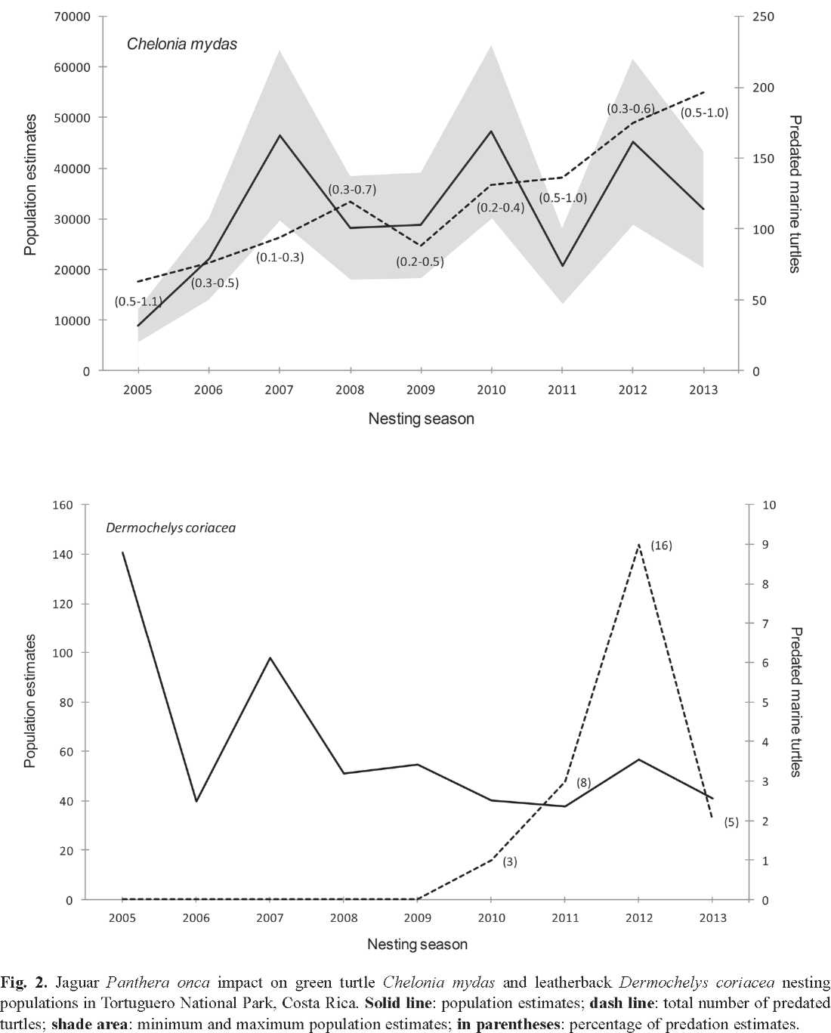
in predation, there was not a significant difference between years (H= 10.136, d.f.= 8, p= 0.256). In all years, predation events were higher during the peak of the green turtle nesting season (from mid-July to mid-October). Data also indicated that predation increased as the nesting population increased (and vice versa) and that jaguars consumed annually an average of 120 green turtles (SD= 45; Fig. 2).
Since 2005, jaguars predated a total of 15 leatherbacks with no predation events documented until 2010 (Fig. 2); predation events
Rev. Biol. Trop. (Int. J. Trop. Biol. ISSN-0034-7744) Vol. 63 (3): 815-825, September 2015
5
occurred only between February to May. It seems that jaguar predation also increased as the nesting population increased, and that jaguars consumed an average of 2 leatherbacks per year (SD= 3; Fig. 2). A total of 17 hawks-bills (mean±SD= 2±2 kills per year) were also predated by jaguars with no kills reported during 2006 and 2008; predation events occurred between April to November.
Data indicated that the distribution of predated turtles and jaguar presence varied spatially, and revealed distinct high-density areas across the coastal habitat. In 2005 three major hotspots for both predation and jaguar activity were identified within the study area (Fig. 1A and Fig. 1C). Predation hotspots encompassed up to four predated turtles. Over the years, there was a shift of both predation and jaguar presence to the Southern sector of the beach. By 2013 four predation hotspots were identified (Fig. 1B) encompassing sites with up to 18 predated turtles. The Southern sector of the beach also seems to be a core area of jaguar activity (Fig. 1D).
DISCUSSION
Throughout the years jaguar predation on green turtles was significantly higher compared to that of leatherbacks and hawksbills, which could be attributed to its abundance and availability. In Tortuguero beach, the estimated green turtle nesting population is significantly larger than the leatherback and hawksbill (Troeng & Rankin, 2005; Troeng, Harrison, Evans, Haro, & Vargas, 2007; Galean & Harrison, 2012). Furthermore, green nesting season occurs over a longer period of time (from February to November) compared to the leath-erback (from February to May) and hawksbill (sporadic nesting throughout the year). Several researches (Karanth & Sunquist, 1995; Gonzalez & Miller, 2002; Polisar et al., 2003; Azevedo & Murray, 2007) suggest that prey abundance and prey availability are the most important ecological factors that explain prey selectivity in large felids.
The higher predation on green turtles could also be due to changes in the presence of jaguars throughout the season. In Tortuguero beach, jaguar presence tends to be lower during the leatherback nesting season but increases as the green nesting season approaches (Arroyo-Arce, unpublished). This pattern could respond to jaguars restricting their movement patterns to the coastal habitat in the months when there is greater prey availability (green nesting season, Arroyo-Arce et al., 2014). Other studies also showed how movement and activity patterns of jaguars depend on those of their main prey (Rabinowitz & Nottingham, 1986; Carrillo, Fuller, & Sáenz, 2009; Harmsen, Foster, Silver, Ostro, & Doncaster, 2011).
The increase in marine turtle predation reported since 1981 could be related to habitat degradation (due to the expansion of the agricultural frontier) that took place inland across the Park's buffer zone in the early 1990s (Troeng, 2000a; Arroyo-Arce et al., 2014). Another factor potentially influencing predation rates is the apparent decline of the main prey species (e.g. Tayassu pecari, Mazama americana, Cuniculus paca and Dasyprocta punctata) due to illegal hunting inside the Park (Troeng, 2000a; Arroyo-Arce et al., 2014). These anthropogenic pressures may be playing an important role in driving the jaguars towards the coastal habitat, and causing the felid to increasingly select marine turtles as prey (Troeng, 2000a; Veríssimo et al., 2012; Arroyo-Arce et al., 2014). An increase in the local population of jaguars could also explain the increase in predation rates (Arroyo-Arce, unpublished). Although jaguars have been observed in Tortuguero beach since the 1950s (Harrison, Troeng, & Fletcher, 2005) there were no population estimates until 2010, when cameras traps where first used. Since then, the number ofjaguars preying on marine turtles has increased from two males to 15 (3 adult males, 2 cub males, 7 adult females, 1 cub female, 1 adult unsexed and 1 cub unsexed) individuals by 2013 (Arroyo-Arce, unpublished).
Our results suggest that current predation rates do not represent a significant threat to the
6
Rev. Biol. Trop. (Int. J. Trop. Biol. ISSN-0034-7744) Vol. 63 (3): 815-825, September 2015
©®©
green turtle population that nest in Tortuguero beach (Troeng, 2000a), which differs from Verissimo et al. (2012) who mentioned that jaguar predation should be considered as one of the highest threats. Some authors (Troeng, 2000a; Campbell & Lagueux, 2005) mention that human activities (e.g. illegal poaching, commercial fishing) have a greater impact than jaguar predation. For example, in 1996 at least 10 166 green turtles were captured by commercial fishing in the feeding grounds of Nicaragua (Lagueux, 1998); individuals that are most likely from the Tortuguero population (Bass, Lagueux, & Bowen, 1998). In 1997 an estimate of 1 783 green turtles females were taken by humans at Tortuguero beach (Troeng, 1997), however, only four individuals were predated by jaguars (Troeng, 1997; Troeng, 2000a). Another threat is the population of feral domestic dogs (Canis familiaris) in Tortuguero village (Verissimo et al., 2012), which have predated nearly 388 nests during the period 2005-2012 (Sea Turtle Conservancy, 2014). The higher predation rates occurred in 2007
and 2010 with 199 and 180 nests poached,
respectively (Debade, Nolasco, & Harrison, 2008; Atkinson, Nolasco, & Harrison, 2011). Other species predating upon nests or hatch-lings while on the beach are coatis (Nasua narica), black vulture (Coragyps atratus), turkey vulture (Cathartes aura) as well as ghost crabs (Ocypode quadrata; Sea Turtle Conservancy, 2014). It is important to highlight that in despite of these threats, the Tortuguero green turtle population has increased by 61% since 1986 (Troeng & Rankin, 2005).
The leatherback nesting population in Tor-tuguero beach is subject to much adversity, with a population decreasing by 67 % during the period 1995 and 2006 (Troeng et al., 2007). A similar pattern has been reported in two other beaches (Gandoca and Pacuare) near Tortuguero (Troeng, Chacon, & Dick, 2004). Some factors that could be contributing to the decline in the local leatherback population are mortality of adults and juveniles in fisheries by 'catch' in feeding areas, and illegal poaching of female turtles and nests in Tortuguero and nearby beaches (Troeng et al., 2004; Troeng et al., 2007; Sea Turtle Conservancy, 2014). Jaguar predation on leatherbacks was first reported in 1999, and predation rates fluctuated greatly throughout the seasons. It is not clear if jaguar predation on leatherbacks is having a significant effect on the turtle's population decline, but we believe it is not the main cause as the number of predated leatherbacks between 1997 and 2006 was only three while the population had a significant decline during roughly the same period (Troeng et al., 2007).
In Tortuguero National Park, there has also been a significant decline in the hawksbill nesting population during the period from 1956
to 2003 (Bjorndal, Bolten, & Lagueux, 1993; Meylan, & Donnelly, 1993; Troeng, Dutton, & Evans, 2005). This species faces similar threats to that suffered by other marine turtles such as commercial exploitation (e.g. eggs, meat and carapace) and incidental capture in fishing gear (Meylan & Donnelly, 1993; Troeng et al., 2005). As with leatherbacks, jaguar predation of this species has been observed at irregular intervals, fitting to the sporadic nesting behaviour of this species in Tortuguero. Therefore, we consider that current predation rates do not represent a significant threat to the local nesting population. However, Troeng et al. (2005) indicated that jaguar predation may prevent population recovery of this species in Tortuguero beach. This could hold true for leatherbacks as well.
Jaguars tend to avoid human-dominated areas (Cullen, Sana, Lima, Abreu, & Uezu, 2013). Therefore, it is expected that the core areas of jaguar activity, and therefore predation, are localized away from Tortuguero village, which is located in the North end of the beach. The far South end of the beach also reported lower numbers of both predation and jaguar activity, which could be related to the presence of a small ranch, a coconut plantation and a research station located in this end of the beach, as well as the presence of Parismina village located on the other side of Jalova River mouth. A similar pattern was described by Verissimo et al. (2012).
Rev. Biol. Trop. (Int. J. Trop. Biol. ISSN-0034-7744) Vol. 63 (3): 815-825, September 2015
7
Our data also shows that the higher predation rates occur in areas with a higher nesting density. In Tortuguero beach, turtle nesting density tended to be lower closer to Tortuguero and Jalova river mouths, which are the least stable areas of nesting habitat (Gonzales, Guerrero, & Harrison, 2013). Further, between the period from 2005 to 2013 the higher nesting levels were recorded between kilometers 6 and 22
(Haro & Troeng, 2006; Gonzales et al., 2013)
corresponding with predation hotspots. Hence, the spatial distribution of nesting females along the beach could also be affecting the spatial arrangement of jaguar activity and predation hotspots. This differs from Veríssimo et al. (2012) who considered that turtle presence is not an important predictor for jaguar predation.
This study suggests that jaguar predation do not represent a threat to the population of green turtles that nest in Tortuguero National Park, and it is not the main cause for population decline for leatherbacks and hawksbills. However, there are still major gaps in our understanding of the interaction between jaguars and marine turtles (e.g. do jaguars predation influence marine turtle behavior?). Therefore, it is important to continuously monitor and evaluate this predator-prey relationship in order to understand how it will evolve in the future. Further understanding of this issue will be required for an effective management of the local jaguar population, as well as the marine turtle species that nest in Tortuguero National Park.
Our findings also stress the potential importance of Tortuguero beach to support the local jaguar population. The beach not only hosts a stable prey community (marine turtles) but also contains a known population of resident and migratory jaguars (which can facilitate gene flow and connectivity between populations) as well as being a breeding area and parenting site (I. Thomson, personal communication, October 1, 2014). The conservation of this area could be critical for the long term survival of the species in the region. Further research on the abundance of terrestrial prey species for jaguars is also essential to better understand the dynamics of this predator-prey relationship.
ACKNOWLEDGMENTS
Funding was provided by Liz Claiborne Art Ortenberg Jaguar Research Grant Program at Panthera, The Rufford Small Grants Foundation, Idea Wild and Global Vision International. We gratefully acknowledge all the staff and volunteers of Global Vision International for their support throughout the execution of this investigation; especially country director Blaine Clarke. We also thank the Área de Conservación Tortuguero/SINAC for giving us permission to work in Tortuguero National Park and for their logistical support. Thanks to I. Thomson for reviewing the English version.
RESUMEN
Efecto de la depredación por jaguares, Panthera onca (Carnívora: Felidae), sobre las poblaciones de tortugas marinas de Tortuguero, costa caribeña de Costa Rica. Existe poco conocimiento sobre el impacto que tienen los jaguares sobre las tortugas marinas que anidan en el Parque Nacional Tortuguero, Costa Rica. Este estudio evaluó el impacto de la depredación de jaguar sobre tres especies de tortugas marinas (Chelonia mydas, Dermo-chelys coriácea y Eretmochelys imbricata) que anidan en Tortuguero. Los reportes de depredación fueron obtenidos empleando dos metodologías, revisión literaria (eventos registrados antes del 2005) y monitoreos semanales a lo largo de la playa (durante el periodo 2005-2013). La depredación del jaguar se ha incrementado de una tortuga en 1981 a 198 tortugas en 2013. Asimismo, los jaguares consumieron anualmente un promedio de 120 (SD= 45) y 2 (SD= 3) tortugas verdes y tortugas baula en Tortugue-ro, respectivamente. Nuestros resultados indican que los jaguares no representan una amenaza para la población de tortugas verdes que anida en Tortuguero, y no son la causa principal de la disminución poblacional de la tortuga baula y carey. No obstante, se recomienda continuar con el monitoreo con el fin de entender cómo esta interacción depredador-presa evolucionará en el futuro.
Palabras clave: Chelonia mydas, Dermochelys coriacea, Eretmochelys imbricata, tortugas marinas, Panthera onca, interacción depredador-presa, Parque Nacional Tortuguero.
8
Rev. Biol. Trop. (Int. J. Trop. Biol. ISSN-0034-7744) Vol. 63 (3): 815-825, September 2015
©®©
REFERENCES
Arroyo-Arce, S., Guilder, J., & Salom-Pérez, R. (2014). Habitat features influencing jaguar Panthera onca (Carnivora: Felidae) occupancy in Tortuguero National Park, Costa Rica. Revista de Biología Tropical, 62(4), 1449-1458.
Arroyo-Arce, S., & Thomson, I. (2015). Jaguar Project Manual: Tortuguero National Park, Costa Rica. Heredia, Costa Rica.
Atkinson, C., Nolasco, D., & Harrison, E. (2011). Report on the 2010 green turtle program at Tortuguero, Costa Rica (Technical Report). San José, Costa Rica: Caribbean Conservation Corporation.
Autar, L. (1994). Sea turtles attacked and killed by jaguars in Suriname. Marine Turtle Newsletter, 67, 11-12.
Azevedo, F., & Murray, D. L. (2007). Spatial organization and food habits of jaguars (Panthera onca) in a floodplain forest. Biological Conservation, 137(1), 391-402.
Barca, B. (2013). Dealing with Conservation Overflows: working with conflict in Tortuguero National Park, Costa Rica. (Master's thesis). University of Oxford, United Kingdom.
Bass, A. L., Lagueux, C. J., & Bowen, B. W. (1998). Origin of green turtles, Chelonia mydas, at "sleeping rocks" off the northeast coast of Nicaragua. Copeia, (4), 1064-1069.
Bermudez, F. A. & Hernandez, C. (2004). Plan de manejo del Parque Nacional Tortuguero (Informe Técnico). San José, Costa Rica: Ministerio del Ambiente y Energía.
Bjorndal, K. A., Bolten, A. B., & Lagueux, C. J. (1993). Decline of the nesting population of hawksbill turtles at Tortuguero, Costa Rica. Conservation Biology,
7(4), 925-927.
Bornatowski, H., Heithaus, M. R., Batista, C. M. P., &
Mascarenhas, R. (2012). Shark scavenging and predation on sea turtles in northeastern Brazil. Amphi-
bia-Reptilia, 33, 495-502.
Campbell, C. L., & Lagueux, C. J. (2005). Survival probability estimates for large juvenile and adult green turtles (Chelonia mydas) exposed to an artisanal marine turtle fishery in the Western Caribbean. Her-
petologica, 61(2), 91-103.
Carrillo, E., Morera, R., & Wong, G. (1994). Depredación de tortuga lora (Lepidochelys olivacea) y de tortuga verde (Chelonia mydas) por el jaguar (Panthera onca). Vida Silvestre Neotropical, 3(1), 48-49.
Carrillo, E., Fuller, T. K., & Sáenz, J. C. (2009). Jaguar (Panthera onca) hunting activity: effects of prey distribution and availability. Journal of Tropical Ecology, 25(5), 563-567.
Cuevas, E., Faller-Menéndez, J. C., fe Angulo, A. (2014).
Marine turtles and jaguars: two mystical species coexisting on the coast of Quintana Roo, México. Retrieved from http://casablancafishing.com/wp-content/ uploads/2013/07/Jaguars-and-Marine-Turtles.pdf
Cullen, L., Sana, D. A., Lima, F., Abreu, K. C., fe Uezu, A. (2013). Selection of habitat by the jaguar, Panthera onca (Carnivora: Felidae), in the upper Paraná River,
Brazil. Zoologia, 30(4), 379-387. Debade, X., Nolasco, D., e Harrison, E. (2008). Report
on the 2007 green turtle program at Tortuguero, Costa Rica (Technical Report). San José, Costa Rica: Caribbean Conservation Corporation.
Fergusson, I. K., Compagno, L. J. V., e Marks, M. A. (2000). Predation by white sharks Carcharodon carcharias (Chondrichthyes: Lamnidae) upon chelo-nians, with new records from the Mediterranean Sea and a first record of the ocean sunfish Mola mola (Osteichthyes: Molidae) as stomach contents. Environmental Biology of Fishes, 58, 447-453.
Fitzpatrick, R., Thums, M., Bell, I., Meekan, M. G., Stevens, J. D., Barnett, A. (2012). A comparison of the seasonal movements of tiger sharks and green turtles provides insight into their predator-prey relationship, Plos One, 7, 1-11.
Fretey, J. (1977). Cuases de motalite des tortues luth adults (Dermochelys coriacea) sur le littoral guayanais. Courrier de la Nature, 52, 257-266.
Galeán, L., Harrison, E. (2012). Report on the 2011 leatherback turtle program at Tortuguero, Costa Rica (Technical Report). San José, Costa Rica: Caribbean Conservation Corporation.
Gonzalez, C. A. L., e Miller, B. J. (2002). Do jaguars
Panthera onca depend on large prey. Western North
American Naturalist, 62(2), 218-222.
Gonzales, C., Guerrero, J. D., e Harrison, E. (2013). Reporte final del programa de tortuga verde 2012 en Tortuguero, Costa Rica (Technical Report). San José, Costa Rica: Caribbean Conservation Corporation.
Harmsen, B. J., Foster, R. J., Silver, S. C., Ostro, L. E. T.,
e Doncaster, C. P. (2011). Jaguar and puma activity patterns in relation to their main prey. Mammalian
Biology, 76(3), 320-324. Haro, A., e Troëng, S. (2006). Report on the 2005 green
turtle program at Tortuguero, Costa Rica (Technical Report). San José, Costa Rica: Caribbean Conservation Corporation.
Harrison, E., e Troëng, S. (2003). Report on the 2002
green turtle program at Tortuguero, Costa Rica (Technical Report). San José, Costa Rica: Caribbean Conservation Corporation.
Harrison, E., e Troëng, S. (2004). Report on the 2003
green turtle program at Tortuguero, Costa Rica
Rev. Biol. Trop. (Int. J. Trop. Biol. ISSN-0034-7744) Vol. 63 (3): 815-825, September 2015
9
(Technical Report). San José, Costa Rica: Caribbean Conservation Corporation.
Harrison, E., & Troeng, S. (2005). Report on the 2004 green turtle program at Tortuguero, Costa Rica (Technical Report). San José, Costa Rica: Caribbean Conservation Corporation.
Harrison, E., Troeng, S., & Fletcher, M. (2005). Jaguar predation of green turtles (Chelonia mydas) at Tortu-guero, Costa Rica. Recovered from http://www.nmfs. noaa.gov/pr/pdfs/species/
Hays, G. C. (2008). Sea turtles: a review of some key recent discoveries and remaining questions. Journal of Experimental Marine Biology and Ecology, 356, 1-7.
Heithaus, M. R., Frid, A., Wirsing, A. J., Dill, L. M., Four-qurean, J. W., Burkholder, D., Thomson, J., & Bejder, L. (2007). State-dependent risk-taking by green sea turtles mediates top-down effects of tiger shark intimidation in a marine ecosystem. Journal of Animal Ecology, 76(5), 837-844.
Heithaus, M. R., Wirsing, A. J., Thomson, J. A., &
Burkholder, D. A. (2008). A review of lethal and
non-lethal effects of predators on adult marine turtles.
Journal of Experimental Marine Biology and Ecology, 356(1-2), 43-51.
Holdridge, L. (1969). Ecología basada en zonas de vida. San José, Costa Rica: Instituto Interamericano de Ciencias Agrícolas.
Karanth, K. U., & Sunquist, M. E. (1995). Prey selection by tiger, leopard and dhole in tropical forest. Journal
of Animal Ecology, 64, 439-450.
Keeran, D. (2013). Jaguars killing endangered marine turtles almost for fun. Recovered from http://www. kaieteurnewsonline.com/2013/07/14/jaguars-killing-endangered-marine-turtles-almost-for-fun-conserva-tionist/
Lagueux, C. J. (1998). Marine turtle fishery of Caribbean Nicaragua: human use patterns and harvest trends. (Master's thesis). University of Florida, Gainesville,
USA.
Mangel, J., & Troeng, S. (2001). Report on the 2000 green turtle program at Tortuguero, Costa Rica (Technical Report). San José, Costa Rica: Caribbean Conservation Corporation.
Meylan, A. B., & Donnelly, M. (1993). Status justification for listing the hawksbill (Eretmochelys imbricata) as critically endangered on the 1996 IUCN Red List of Threatened Animals. Chelonian Conservation and
Biology, 3(2), 200-224. Nelson, E. H., Matthews, C. E., & Rosenheim, J. A. (2004).
Predators reduce prey population growth by inducing changes in prey behavior. Ecology, 85(7), 1853-1858.
Ortiz, R. M., Plotkin, P. T., & Owens, P. W. (1997). Predation on olive ridley sea turtles (Lepidochelys olivacea) by the American crocodile (Crocodylus acutus) at Playa Nancite, Costa Rica. Chelonian Conservation and Biology, 2(4), 585-587.
Pitman, R. L., Dutton, P. H. (2004). Killer whale predation on a Leatherback Turtle in the Northeast Pacific.
Pacific Science, 58(3), 497-498.
Polisar, J., Maxit, I., Scognamillo, D., Farrel, L., Sunquist, M. E., e Eisenberg, J. E. (2003). Jaguars, pumas, their prey base, and cattle ranching: ecological interpretations of a management problem. Biological Conservation, 109(2), 297-310.
Rabinowitz, A. R., fe Nottihgham, B. G. (1986). Ecology and behavior of the jaguar (Panthera onca) in Belize, Central America. Journal of Zoology, 210, 149-159.
Reyes, C., Troëng, S. (2001). Report on the 2001 leatherback program at Tortuguero, Costa Rica (Technical Report). San José, Costa Rica: Caribbean Conservation Corporation.
Reyes, C., e Troëng, S. (2002). Report on the 2001 green
turtle program at Tortuguero, Costa Rica (Technical Report). San José, Costa Rica: Caribbean Conservation Corporation.
Sea Turtle Conservancy. (2014). STC Programs: Research: Tortuguero Season Reports. Recovered from http://www.conserveturtles.org/costarica. php?page=season-reports.
Spotila, J. R., Dunham, A. E., Leslie, A. J., Steyermark, A. C., Plotkin, P. T., fe Paladino, F. V. (1996). Worldwide population decline of Dermochelys coriacea: are leatherbacks turtles going extinct? Chelonian
Conservation Biology, 2(2), 209-222.
Troëng, S. (1997). Report on the 1997 green turtle program at Tortuguero, Costa Rica (Technical Report). San José, Costa Rica: Caribbean Conservation Corporation.
Troëng, S. (1999). Report on the 1998 green turtle program at Tortuguero, Costa Rica (Technical Report). San José, Costa Rica: Caribbean Conservation Corporation.
Troëng, S. (2000a). Predation of green (Chelonia mydas) and leatherback (Dermochelys coriacea) turtles by jaguar (Panthera onca) at Tortuguero National Park, Costa Rica. Chelonian Conservation and Biology,
3(2), 751-753.
Troëng, S. (2000b). Report on the 1999 green turtle program at Tortuguero, Costa Rica (Technical Report). San José, Costa Rica: Caribbean Conservation Corporation.
Troëng, S. (2000c). Report on the 1999 leatherback program at Tortuguero, Costa Rica (Technical Report). San José, Costa Rica: Caribbean Conservation Corporation.
Troëng, S., Chacón, D., e Dick, B. (2004). Possible decline
in leatherback turtle Dermochelys coriacea nesting
10
Rev. Biol. Trop. (Int. J. Trop. Biol. ISSN-0034-7744) Vol. 63 (3): 815-825, September 2015
©®©
along the coast of Caribbean Central America. Oryx, 35(4), 395-403.
Troeng, S., Dutton, P. H., & Evans, D. (2005). Migration of hawksbill turtles Eretmochelys imbricata from Tortuguero, Costa Rica. Ecography, 25, 394-402.
Troeng, S., & Rankin, E. (2005). Long-term conservation efforts contribute to positive green turtle Chelonia mydas nesting trend at Tortuguero, Costa Rica. Biological Conservation, 121 , 111-116.
Troeng, S., Harrison, E., Evans, D., Haro, A., & Vargas, E. (2007). Leatherback turtle nesting trends and threats at Tortuguero, Costa Rica. Chelonian Conservation and Biology, 6(1), 117-122.
Valeix, M., Loveridge, A. J., Chamaillé-Jammes, S., Davidson, Z., Murindagomo, F., Fritz, H., & Macdonald, D. W. (2009). Behavioral adjustments of African herbivores to predation risk by lions: spatiotemporal variations influence habitat use. Ecology, 90(1), 23-30.
Verissimo, D., Jones, D. A., Chaverri, R., & Meyer, S. R. (2012). Jaguar Panthera onca predation of marine turtles: conflict between flagship species in Tortuguero, Costa Rica. Oryx, 46(3), 340-347.
Worton, B. J. (1989). Kernel methods for estimating the utilization distribution in home-range studies. Ecology, 70(1), 164-168.
Rev. Biol. Trop. (Int. J. Trop. Biol. ISSN-0034-7744) Vol. 63 (3): 815-11, September 2015
825

